Project 1 Written Analysis

Group Collaborators:
Martin Carriel, Addison Pietroburgo, Joshua Steinmetz, Scott Stevener

- How do Missourians commute?

- As expected, as massive majority of Missourians commute alone by car (represented in the US census as “Solo Commuters”). A resounding 86% of all Missourians are “Solo Commuters”.

- Carpoolers are the second largest group of commuters and make up 10% of all Missouri commuters.

- Public Transit riders and Walkers accounted for two percent each, and Other commuters (i.e. motorcycle, boat, bicycle) made up the remaining percentage points.

- Commuter rates were mostly similar across Missouri, with between 40% to 50% of the population commuting. The highest commuter rates are concentrated around the state’s largest metropolitan areas, Kansas City and St. Louis, and along the Interstate 44 corridor.

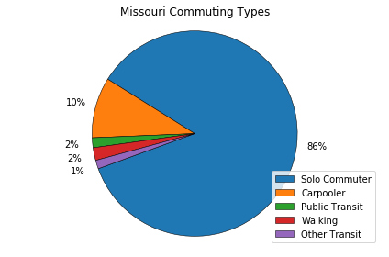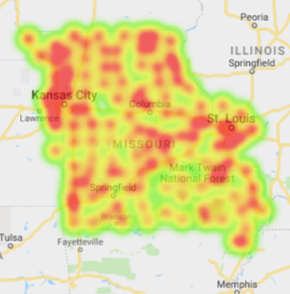

- What differences exist for commuting types across counties in Missouri?

- We considered a county metropolitan if it was in the Metropolitan Statistical Area of the top 3 cities in Missouri (Kansas City, St. Louis, Springfield).

- A Chi-Squared Test revealed that neither rural nor metro samples differed significantly from the Missouri averages for each commute type.

- An Independent T-Test revealed that the rates of Carpooling and Walking are significantly different between metro and rural counties. This could be due to the possibility that people in rural counties generally live within walking distance to their place of work (i.e. farmers) and that fewer employers in rural counties could make carpooling a better option.

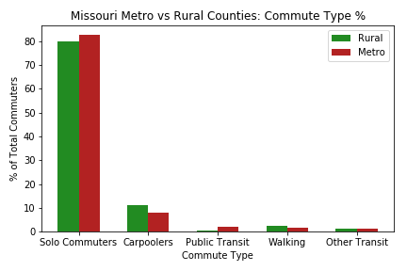

- What differences exist for commuting types within metropolitan areas in Missouri?

- When comparing the different metro areas in Missouri, we considered the entire Metropolitan Statistical Area (MSA) for each of the top three cities in Missouri (Kansas City, St. Louis, Springfield). The MSAs of Kansas City and St. Louis included counties from neighboring states.

- An ANOVA Test revealed significant differences in Commuter %, Carpooler %, and Other Transit % among the MSAs.

- When subjecting each pair of cities to a T-Test for each category, only the difference in Carpooler % between Kansas City and St. Louis MSAs was significant.

- Despite lower p-values in these T-Tests, the small number of counties in the Springfield MSA (5) prevented higher probabilities of differences with the other two MSAs.

- Springfield has a larger population of people who commute by walking which also correlates with a larger percentage of commuters who carpool. This could be due to the possibility that many people who live in Springfield live or work near their place of work (i.e. a college campus, manufacturing facility, medical complex).

